
STORE2DOOR BUSINESS PLAN
by Amadou M Sow

Name: Amadou Sow Student number: ST10443406 Module: BMNG6221Assessment: Portfolio of evidence Lecturer: Ms P Kojane Group: 3

TABLE OF CONTENTS
(i)Executive Summary…………………………………………………………………… 2
1. BUSINESS AND PRODUCT DESCRIPTION ………………………….…………. 1
1.1 Short business description …………………………………………………………. 5
1.2 Trademarks and copyrights ………………………………………………………… 5
2. MARKETING PLAN…………………………………………………………………… 6
2.1 Market description …………………………………………………………………… 6
2.2 Location ……………………………………………………………………………….. 6
2.3. Potential market share ……………………………………………………………… 7
2.4 Target market …………………………………………………………………………. 7
2.5 Identified competitors ………………………………………………………………… 8
2.6 Product pricing strategies ……………………………………………………………. 8
2.6.1 A flat rate …………………………………………………………………….. 8
2.6.2 Time based ………………………………………………………………….. 8
2.6.3 Tiered packaged pricing …………………………………………………… 8
2.6.4 Subscription based pricing ………………………………………………… 8
2.7 Advertising …………………………………………………………………………….. 9
2.8 Promotional Strategies ………………………………………………………………. 9
2.8.1 Coupons and deals ……………………………………………………… 10
2.8.2 Free trials …………………………………………………………………. 10
2.8.3 Customer loyalty programs ……………………………………………… 10
2.9 Growing the business from a marketing perspective …………………………… 10
2.9.1 Phase 1: Customer trust and word of mouth ……………………………10
2.9.2 Phase 2: Expand service areas …………………………………………. 10
2.9.3 Phase 3: Build a brand ……………………………………………………. 11
2.9.4 Phase 4: Partner with local businesses …………………………………. 11
2.9.5 Phase 5: Introduce technology …………………………………………… 11
3. FINANCIAL PLAN ……………………………………………………………………. 11
3.1 Budget of the first two months of operation ………………………………………. 12
3.2 Projected statement of financial position …………………………………………. 13
3.3 Projected statement of profit and loss …………………………………………….. 14
3.4 Break-even point …………………………………………………………………….. 15
4. OPERATIONAL PLAN ……………………………………………………………….. 16
4.1 Key processes ……………………………………………………………………….. 16
4.1.1 Input acquisition …………………………………………………………… 16
4.1.2 Customer interaction ……………………………………………………… 16
4.1.3 Customization ……………………………………………………………… 17
4.1.4 Feedback and improvement ……………………………………………… 17
4.1.5 Support processes ………………………………………………………… 17
4.1.6 Service delivery ……………………………………………………………. 18
4.2 Key structures ………………………………………………………………………... 18
4.2.1 Physical facilities …………………………………………………………... 18
4.2.2 Technology Systems ………………………………………………………. 18
4.2.3 Human resources …………………………………………………………. 19
4.2.4 Organizational structure ………………………………………………….. 19
4.3 Key strategies ……………………………………………………………………….. 19
4.3.1 Customer focus strategies ……………………………………………….. 19
4.3.2 Differentiation strategies …………………………………………………. 19 4.3.3 Cost leadership strategies ………………………………………………. 20
4.4 Description of Key personnel in the 7-business departments ………………….. 20
4.4.1 Operations …………………………………………………………………. 21
4.4.1.1 Chief operations officer (COO) ………………………………… 21
4.4.1.2 Operations manager ……………………………………………. 21
4.4.1.3 Logistics supervisor …………………………………………….. 21
4.4.1.4 Quality control officer …………………………………………… 21
4.4.1.5 Delivery Team / Production workers …………………………... 21
4.4.2 Sales ………………………………………………………………………... 22
4.4.2.1 Chief sales officer (CSO) ……………………………………….. 22
4.4.2.2 Sales manager …………………………………………………... 22
4.4.2.3 Key account manager …………………………………………... 22
4.4.2.4 Sales representatives …………………………………………... 22
4.4.2.5 Sales support assistance ………………………………………. 22
4.4.3 Marketing …………………………………………………………………… 22
4.4.3.1 Chief marketing officer (CMO) …………………………………. 23
4.4.3.2 Marketing officer ………………………………………………… 23
4.4.3.4 Digital marketing specialist …………………………………….. 23
4.4.3.5 Content creators/ Designers …………………………………… 23
4.4.4 Finance ……………………………………………………………………... 23
4.4.4.1 Chief financial officer (CFO) ……………………………………. 23
4.4.4.2 Finance manager/ Controller …………………………………... 23
4.4.4.3 Accountants ……………………………………………………… 24
4.4.4.4 Payroll officer ……………………………………………………. 24
4.4.4.5 Finance assistance ………………………………………………24
4.4.5 Human resources …………………………………………………………. 24
4.4.5.1 Chief human resources officer (CHRO) ………………………. 24
4.4.5.2 HR manager ……………………………………………………... 24
4.4.5.3 Recruitment officer ……………………………………………… 24
4.4.5.4 Training and development officer ……………………………… 24
4.4.5.5 HR Assistance …………………………………………………… 24
4.4.6 Information technology ……………………………………………………. 24
4.4.6.1 Chief information officer (CIO) …………………………………. 24
4.4.6.2 IT manager ………………………………………………………. 25
4.4.6.3 System administration ………………………………………….. 25
4.4.6.4 Help desk support technicians ………………………………… 25
4.4.7 Administration ……………………………………………………………… 25
4.4.7.1 Administrative manager ………………………………………… 25
4.4.7.1 Administrative assistance ………………………………………. 25
4.5 Structure of transformational model ……………………………………….. 25
4.7 Transformational model …………………………………………………….. 26
4.6 Business approach to planning and management ………………………. 28
4.8 Contract of employment ……………………………………………………. 29
5. CONCLUSION ……………………………………………………………………….. 38
6. REFERENCE LIST …………………………………………………………………… 38

(i) EXECUTIVE SUMMARY

- BUSINESS AND PRODUCT DESCRIPTION

1.1 Short business description
Store2Door is a service rendering business, based in Midrand in Johannesburg South Africa. Customers use Store2Door to go to the stores and shops such as Checkers and Woolworths for groceries and such and becomes the middleman that brings items from party A (e.g. a grocery store or a mechanic’s shop) to party B (the client or a designated address). The purpose of this business is to mitigate the National Development Plan issue of South Africa’s high unemployment rate by creating jobs that will employ a large number of otherwise unemployed individuals with varying skillsets and abilities. The ideal areas that the business will draw employees will be areas where unemployment is common and there is high levels of job seeking individuals.
1.2 Trademarks and copyrights

Store2Door (Pty) Ltd is a registered private company with the CIPC registration number: 2023/123456/07. As a service-based business, intellectual property protection is focused on trademarks and copyright, rather than patents.
The company’s name, logo, and branding elements have been registered as a trademark with the Companies and Intellectual Property Commission (CIPC), ensuring that Store2Door’s brand is legally protected and cannot be used by other businesses in the same class of goods or services.
In South Africa, copyright is automatically granted upon the creation of original works, such as website content, software code, promotional material, and app design. While formal registration of copyright is not a legal requirement, creators are encouraged to document and timestamp their work for stronger legal protection in the event of disputes (Van der Walt, 2020). Copyright is not registered through CIPC but is instead protected by section 3 of the Copyright Act (Act 98 of 1978), provided the work meets the requirements of originality and fixation.
Together, these intellectual property protections help secure Store2Door’s unique identity, brand value, and digital assets under South African law.
The business would be incorporated along with a Memorandum of Incorporation (MOI), shareholder agreements, the required number of directors, a public officer, and other laws and regulations (Fulbright, 2015). These include the labour and environmental regulations, as well as tax compliance (SME South Africa, 2023).

- MARKETING PLAN

The marketing plan of Store2Door is made up of a multi-faceted approach based on the current market conditions and the business’s goals to penetrate and make a ever growing place for itself in said market.

2.1 Market description
This step includes a market description. A market description speaks on the size, characteristics and parts of the market that a business would target. Doing this helps define the target market, their location and why they would buy the business’s products or services (Kotler and Keller, 2016, p. 246). Taking this into account, Store2Door would operate in the on-demand delivery, concierge and couriering industry in South Africa, a growing sector influenced by changes in lifestyle, urbanisation, etc. The industry would be made up of e-commerce and logistics, allowing consumers to place their requests via a mobile application or a website platform (Grand View Research, 2019).
2.2 Location
The business’s main office would be located in the Midrand area in Johannesburg, South Africa. This area was chosen specifically due to its proximity to both a clientele pool that is made of Sandton, Centurion and Randburg, amongst others, whilst also being close to areas with high levels of youth unemployment such as Tembisa, whose unemployment rate sits at 34,5% (Charman, 2017). Shologu (2023) further states that the Tembisa youth unemployment rate in the first quarter of 2022 was 63,9%. This makes that area an ideal from a PR standpoint as well to draw employees and independent contractors from areas such as Tembisa.
Having the main offices close to such a large clientele pool would shorten lead times from when the order is placed to when the goods are delivered, this increasing on customer satisfaction and fostering customer loyalty and a reliance to Store2Door’s services and in this way, the good word of the company would spread.

2.3 Potential market share
It is seldom that a company gains a monopoly in its market immediately after its inception. In the infancy of the company i.e. first one to two years, Store2Door is dedicated to obtaining two-point five (2.5) to five (5) percent of the Johannesburg market. This figure is taking into consideration the current players in the market such as Mr D and Uber, who together takes up to ninety (90) percent of the market (George, 2022). Management has set the goal that in the middle term of three to five years of the company’s existence, Store2Door will be more known to the public and therefore garner a larger market share of five (5) to nine (9) percent of the market. The idea is for the business to gain a sustainable growth and ensure the company’s longevity. In the long term of six to ten years, management will set itself to obtain ten (10) to nineteen (19) percent market share at minimum.
2.4 Target market
As this company’s service caters to provide convenience, it is ideally suited for those seeking such luxuries. These would include busy working individuals who have the income for such a service as well as the lack of time availability to warrant the use of such a service. Another target market would be those individuals who are elderly and or are mobility impaired, whose inability to have reliable transport and assistance can be costly, scarce or both. The company’s services can also be useful to SMEs (Small, Medium and Micro enterprises) who cannot afford a driver full time or a method of reliable transport of goods. Such services can also be useful to parents, who for some reason or another require supplies, groceries and errand running for themselves or their children, as having surprise emergencies are commonplace when involving children and their formative years.

2.5 Identified competitors
A hurdle that Store2Door has to overcome is to be a considerable action to the consumer. Among the supermarket chains and other kinds of businesses that exist in Johannesburg, there is a common occurrence that they offer delivery services in house, with examples such as Checkers Sixty60, Pick n Pay ASAP etc, with Checkers Sixty60 being seen as the cheapest (Ivana, 2025). There are also generalist players in the market such as Glovo, Yassir, and WeChow (Kumar, 2025). These are competitors in the market that Store2Door management must take into consideration in order to create and maintain a presence in the market.

2.6 Product pricing strategies
Due to this being a service-based business, it is required that a pricing strategy be tailored to the services offered at Store2Door. Management has floated around different pricing systems for different kinds of customers. They include but are not limited to:
2.6.1 A flat rate: This is where the customer is charged a one stop based, fixed amount per a standard errand or delivery (Binary Stream, 2024). An example of which would be a simple errand that is done at one location like buying a loaf of baked bread.
2.6.2 Time based: A pricing system where customers are charged based on how long an errand takes to complete (Bennett, 2023). An example is having to do errands where one would take five minutes to complete whereas an errand taking fifty minutes or one hour to complete.
2.6.3 Tiered packaged pricing: This is where customers and pricing levels are set up on a tier-list, with set benefits applicable to customers at each tier (Stripe, 2025). An example is where a higher tiered individual is granted more perks and privileges when compared to individuals who are on a lower valued tier.
2.6.4 Subscription based pricing: This involves charging a customer a recurring fee. This model is versatile, as it caters for many variables that can be integrated into the pricing, such as a premium subscription, basic, advanced, usage based, etc (O’Brien, 2021). An example of this is where a client is subscribed to a basic level and getting appropriate benefits where a higher-level subscriber has access to more perks and advantages.

2.7 Advertising
A great way for a business to tell the public about itself is to advertise. An advertisement, also known as ad or advert is the business telling the public to promote a product, service, event or brand (Square, 2022). Store2Door’s approach to advertising will use both a digital and in person advertising strategy, with the digital aspect having the business establish a digital footprint and a presence on social media such as Facebook, TikTok, and Instagram ads and other short form content platforms to target both the youth and the advanced age. Digital advertising is seen as more cost effective, an excellent return on investment and spreads well amongst a population, among other benefits (Stamoulis, 2015).
The in-person aspect of this strategy will include the use of flyers, public events and direct interactions with the people. The purpose of this is to introduce the business to the public and to foster a more intimate relationship between the two as opposed to digital advertising, as well as gaining the public trust in the business (Crawford, 2024).

2.8 Promotional Strategies
A promotional strategy is how the business wants to create or increase a demand for a product or service. It speaks on how a business will grow awareness on its product or service and get people interested in utilising it (MacNeil, 2025). Store2Door will utilise the following strategies:
2.8.1 Coupons and deals: These are used to capture customers who are undecided on whether or not to use Store2Door’s services (MacNeil, 2025).
2.8.2 Free trials: A common way to introduce a customer to a product or service and to have them feel like they are getting a great deal risk free (MacNeil, 2025).
2.8.3 Customer loyalty programs: These programs incentivise customers to keep using the business. It is a method to retain customers by offering deals, discounts and more perks in the customer’s favour (MacNeil, 2025).

2.9 Growing the company from a marketing perspective
It is imperative that Store2Door’s marketing department has a solid plan that will grow the business from a marketing perspective. It is divided into four phases that begin at the grassroots level:
2.9.1 Phase 1: Customer Trust and word of mouth
In this phase the business starts small, relying on the verbal reviews and praises of the small customers they begin with. Store2Door would use local WhatsApp groups, churches and small business, as they provide spaces for informal client communication, story sharing and marketing (SME South Africa, 2024).
Start with local WhatsApp groups, churches, and small businesses to build personal connections and trust. WhatsApp is widely used in South Africa and is effective for informal client communication and marketing (SME South Africa, 2024). Encourage repeat clients and referrals through loyalty rewards and referral discounts, which help drive word-of-mouth marketing — a powerful tool for local services (Kumar et al., 2019).
2.9.2 Phase 2: Expand Service Areas
Adopt a gradual expansion strategy by launching services neighbourhood-by-neighbourhood, starting in high-demand zones such as Sandton or Randburg. Mini campaigns tailored to each area can increase local awareness and conversion (Campbell, 2017). Recruit local runners to serve each suburb — a strategy proven effective in improving delivery speed and customer trust (Walls, 2025).

2.9.3 Phase 3: Build a Brand
Create a strong brand presence by using cost-effective marketing tools that reinforce both visibility and trust. Outfitting your runners in branded T-shirts and reflective vests not only ensures professionalism and safety, but also increases local brand visibility — effectively turning your workforce into walking advertisements (Hi-Viz.com, 2024). Supporting this, low-cost guerrilla marketing tactics such as consistent visual branding and memorable logos can enhance customer recall and strengthen your brand's offline presence (Shopify, 2023). Establish an online presence through Instagram, Facebook, and eventually a mobile app. This supports visibility, engagement, and customer acquisition (DHL, 2024).

2.9.4 Phase 4: Partner with Local Businesses
Collaborate with local businesses such as pharmacies, salons, and spaza shops. This mutually beneficial relationship helps expand your network and attract recurring business from established customer bases (Gaines, 2011).

2.9.5 Phase 5: Introduce Technology
Once the customer base is stable, invest in a mobile-friendly platform or dashboard to streamline orders and communication. WhatsApp Business tools like automated replies and quick responses can be used to scale without losing personalization (WhatsApp Business, 2023; Skill Space, 2024). Data collected over time can help segment customers and provide personalized promotions (DHL, 2024).

3. FINANCIAL PLAN

Given the startup funding of R250000, in conjunction with an additional R500000 from the disclosure of shares, the figure of R750000 will be used to create the financial statements and budgets.

To understand the expected expenses of Store2Door within the first two months of inception, a budget with the forecasted expenses. Explanations for the figures used will be given in the notes below:
3.1 Budget of the first two months of operation
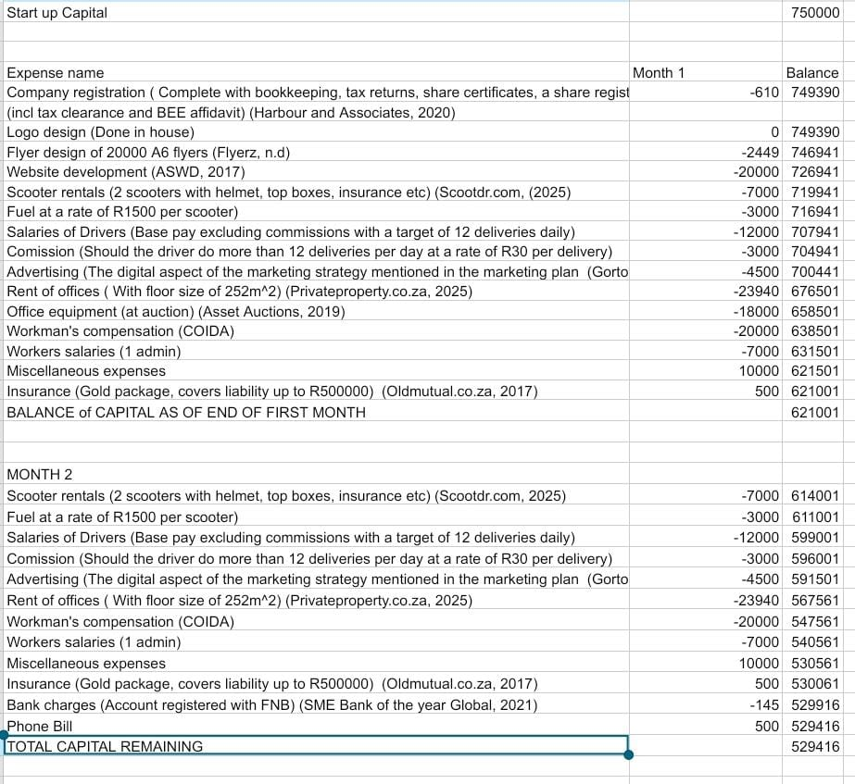
3.2 Projected Statement of Financial Position
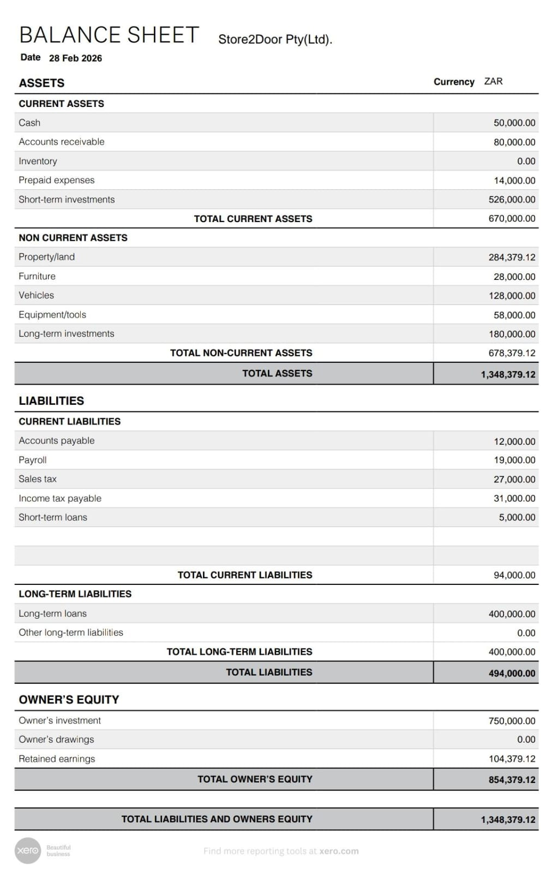(Xero, 2024)
3.3 Projected Statement of Income and Loss
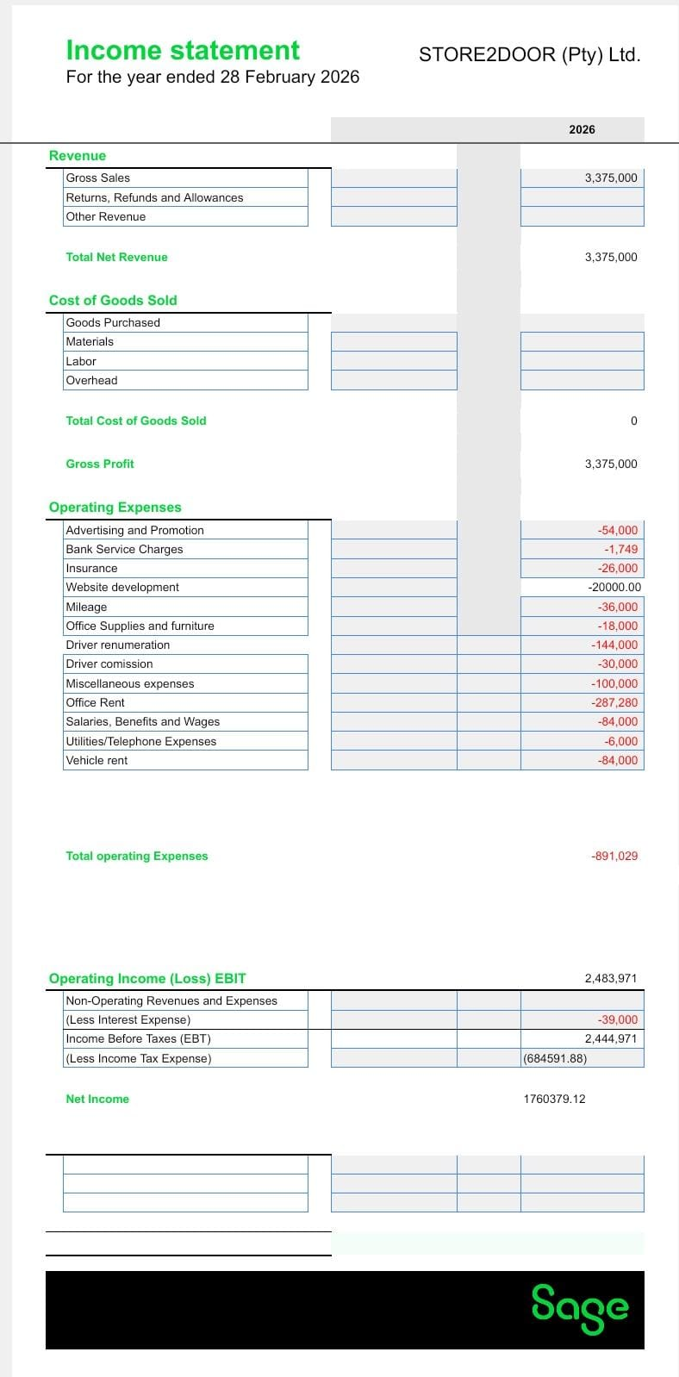 (Malik, 2024)
3.4 Break even point
The break-even point calculation is important for a business to conduct in order to identify the point at which their income and expenses equal zero, and by knowing this, this will help a business make better decisions about selling prices, creating sales forecasts and to prepare a business plan (Queensland Government, 2021).

In a service business like Store2Door, the formula is different from a product or a manufacturing business (Xero, 2023). In the case of Store2Door, management has concluded that the revenue break-even point formula will best suit Store2Door’s financials. The calculation is as follows:

Break-even point (revenue) = Fixed costs (variable costs / Selling cost) or Fixed costs / contribution
(Xero, 2023)
Using the figures from the financial statements, the equation would look as follows:
Contribution margin = sales – variable costs
This can be calculated using a ratio
CM ratio = Operating income/ gross income
CM ratio = 2483971 / 3375000
CM ratio = 0.7359914074 rounded to 73,60%.
Now the break-even point can be calculated
Break even = 891029/0.7359914074
Break even = R1210651,362

The business would need to generate R1 210 651,36 in order to break even.

- OPERATION PLAN

The operational plan, in general terms, is the plan that is set with the task of outlining the business’ plan on how it will organise and manage a product or service (Van Aardt, 2019 p.488). In order to best disclose the business’s operational plan, management needs to understand the transformational process. The transformation process is defined as the change of inputs to outputs. This can be done either manufacturing or service processes and businesses (Edureka, 2022). Store2Door is a service business so it will have a different transformation process compared to a manufacturing business.

  - Key Processes
Key processes are processes that have the largest impact on the business and the customers (Harper, 2020). In the case of Store2Door, the key processes are outlined as:
    - Input acquisition
This is defined as acquiring the needed resources (labour, capital, information etc) to begin the service process (Fitzsimmons & Fitzsimmons, 2013 p.38). In the perspective of Store2Door, input acquisition would be how the business gets the resources to get started. This would be achieved by the initial capital of R250000, the shareholder investment of R500000 to give a total of R750000. The labour will be obtained by employing and contracting job seeking individuals in the Tembisa area, as that area is high in unemployment. The information would be sourced by the market research, social media and other information gathering techniques such as surveys, interviews, etc.
    - Customer interaction
This is defined as how the customer collabs with the business in order for the business to deliver its product or service (Heizer, Render and Munson, 2017 p.10). Store2Door would interact with their customers in the following ways:
a) Having the customer place an order for an errand
b) Confirming the delivery address
c) Having access to communicate with the drivers who are performing the errand
d) Receiving the order or notification that the errand has been completed.
    - Customization
Customization is loosely defined as making changes to something according to the buyer’s or user’s needs (Cambridge Dictionary, 2019 p.46). Store2Door would allow customers to customize their errands and orders by setting delivery times, allowing them to have multiple stops for different errands, changing delivery addresses. Customers would also able to disclose which stores the business must go to for whichever reason, whether it be preference, brand or shop loyalty, special discounts and offers, etc.
    - Feedback and Improvement
This aspect is concerned with collecting customer’s opinions and thoughts of the company, both good and bad in order to provide a better service to the customers (Fitzsimmons & Fitzsimmons, 2013 p.45). Customers would be encouraged by Store2Door to leave reviews, share opinions and such about the business. The reason being so that Store2Door can improve its performance, provide a better service to customers with the goal of claiming a greater share of the market.
    - Support processes
This is having the administration and or Backoffice functions of the organisation supporting the core services of the business (Heizer, Render and Munson, 2017 p.54). In the situation of Store2Door, it would be a constant dealing that the administration, customer support and other such relevant departments would be supporting the main drivers, as the drivers would be the ones that interact with the customers daily. Having support would translate to better response times, a smoother experience for the customers, providing a better service for society, etc.
    - Service delivery
This is where the business actually performs the service and the related activities (Slack, Brandon-Jones and Johnston, 2016 p.10). Store2Door would actually have their drivers and contractors go out to fulfil client’s errands and orders, with the latter being retrieved and delivered to a set destination at the client’s choosing
  - Key Structures
4.2.1 Physical facilities
This speaks of on the physical environment where the service is delivered (Slack, Brandon-Jones and Johnston, 2016 p.21). In the perspective of Store2Door, the physical facilities would include the address(s) that the client has set the order to deliver, or the stores where their errands would take place. Physical facilities also include the business’s main office or depot, etc.
4.2.2 Technology Systems
This structure pertains to the IT infrastructure supporting the service processes (Stevenson, 2020 p.86). Store2Door would made a investment towards creating a digital footprint on social media and online, as well as having mobile applications (apps) and website that advertise the business and its services, and act as a channel of communication between the business and the public at large.
4.2.3 Human Resources
This is the workforce that delivers the service (Fitzsimmons and Fitzsimmons, 2013 p.115). This would be the employees and independent contractors that are employed and contracted by the company respectively. These include both the drivers who perform the errands and orders, as well as the administration and support personnel who act at the backend of the driver’s frontend.
4.2.4 Organizational structure
This pertains to the management and departmental arrangement of the business (Heizer, Render and Munson, 2017 p.60). This will be expanded later on in this business plan.
  - Key Strategies
4.3.1 Customer focus strategy
This strategy entails that a business concentrates on a narrow segment of a market, and within it, tries to get either a cost leadership or advantage or a differentiation strategy (Van Aardt, 2019 p.213). Store2Door, should they take this route, would mean identifying a segment with potential for growth as well as the desired features that will fulfil the business’s short term profit goals, and then implement a strategy that would make the business a worthy business to consider when a customer has a need to fulfil.
4.3.2 Differentiation strategy
A differentiation strategy is a strategy that a business that would cause the business to create a product or provide a service that sets itself apart from other products or services in the market (Van Aardt, 2019 p.213). Store2Door, should this strategy be chosen, would augment the services provided and make it such that it is unique in the market in some way or another when compared to others in the market, thereby distinguishing itself in the market.
4.3.3 Cost Leadership strategy
This strategy is quite generic, but effective, where a business produces a product or service with the lowest cost possible. With such a large gap compared to competitors, it allows the business to absorb more cost fluctuations, whilst also being attractive to customers and the public (Van Aardt, 2019 p.211). Store2Door, if this path is taken, would set itself to making its costs as low as possible while also making their prices at a market level, so that the profit margin is much larger. Another advantage to this would be it would enable the business to survive longer than other competitors who cannot keep up with the cost fluctuations opposed to their own bottom line.
4.4 Description of Key personnel in the 7-business departments
As the business is in its infancy, the budgets created in the financial plan were created with that in mind, specifically, the first two (2) months of incorporation. As the business grows, its departments will grow in accommodation. Below are the key personnel for the following departments
4.4.1 Operations
4.4.2 Sales
4.4.3 Marketing
4.4.4 Finance
4.4.5 Human resources
4.4.6 Administration
4.4.7 Information Technology
4.4.1 Operations Department
4.4.1.1 Chief Operations Officer (COO):
Executive responsible for overall business operations, ensuring alignment with company goals (Slack, Brandon-Jones & Johnston, 2016, p. 5). It is this individual that will provide reports to the CEO and the board to make decisions for the company.
4.4.1.2 Operations Manager:
Directly oversees daily operations, resource management, and scheduling of production or service delivery (Heizer, Render & Munson, 2017, p. 16). This person ensures that the whole process is running smoothly and will provide the data to the COO that will be in the reports.
4.4.1.3 Logistics Supervisor:
Manages supply chain coordination, delivery schedules, and inventory flow (Stevenson, 2020, p. 88). This role requires that the drivers are on time on their jobs, they are notified of any changes to a job, their immediate needs are met like breaks, lunch meals, etc.
4.4.1.4 Quality Control Officer:
Ensures product or service compliance with regulatory and internal quality standards (Fitzsimmons & Fitzsimmons, 2013, p. 47). This individual would ensure that all jobs performed by Store2Door comply with the set standards and quality to ensure a consistent level of service to the customers
4.4.1.5 Delivery Team / Production Workers:
Front-line staff responsible for actual service or product delivery (Fitzsimmons & Fitzsimmons, 2013, p. 45). These are the drivers and contractors renumerated by Store2Door. They are the ones who will fulfil the deliveries and errands for customers

4.4.2 Sales Department
4.4.2.1 Chief Sales Officer (CSO):
Sets strategic sales goals, responsible for achieving revenue targets (Heizer, Render & Munson, 2017, p. 57). Store2Door’s CSO will set the company sales targets, e.g. increasing sales by 7% this quarter, and will be the one who sets the long-term goals in their department. The CSO will generate reports required by the board and the CEO.
4.4.2.2 Sales Manager:
Manages regional or product-specific sales teams, sets daily/weekly sales targets (Slack, Brandon-Jones & Johnston, 2016, p. 112). This individual answers to the CSO. They also oversee the regional teams on their performance and identifies areas of improvement.
4.4.2.3 Key Account Managers:
Handle high-value or long-term clients, maintain client satisfaction and retention (Stevenson, 2020, p. 146). This individual will oversee the overall handling of large clients and their accounts, and to ensure their satisfaction with the business’s services. This person will generate reports for the Sales manager.
4.4.2.4 Sales Representatives:
Conduct new client acquisition, conduct demos, generate leads, and close sales (Fitzsimmons & Fitzsimmons, 2013, p. 51). This person will create accounts for new clients, finds and retains new clientele as well as generate reports to the key account managers.
4.4.2.5 Sales Support Assistants:
Prepare sales materials, maintain CRM databases, and provide administrative support (Stevenson, 2020, p. 149). Sales support the sales reps, and would be the ones to assist clientele, if need be, maintain the data keeping on clientele and generate reports for management.

4.4.3. Marketing department
4.4.3.1 Chief Marketing Officer (CMO):
Responsible for overall branding, market positioning, and campaign success (Fitzsimmons & Fitzsimmons, 2013, p. 101). This individual is the highest in the department, who will then report to the CEO. They must create strategies and campaigns that will improve the business from a marketing perspective. They would be the ones who will fulfil the marketing plan points.
4.4.3.2 Marketing Manager:
Plans specific marketing campaigns, coordinates teams (Slack, Brandon-Jones & Johnston, 2016, p. 294). This person would report to the CMO. They will co-ordinate certain teams to create campaigns.
4.4.3.3 Digital Marketing Specialist:
Manages online marketing, SEO, content, and digital analytics (Stevenson, 2020, p. 326). This person reports to the marketing manager. This person oversees the electronic presence of Store2Door their digital footprint, etc.
4.4.3.4 Market Research Analyst (MRA):
Conducts research to support campaign strategies and market segmentation (Heizer, Render & Munson, 2017, p. 118). This person would report to the marketing manager about current market trends and news.
4.4.3.5 Content Creators / Designers:
Create visual and written marketing content (Slack, Brandon-Jones & Johnston, 2016, p. 296). They create the actual content, such as posters, flyers, etc. They report to and the marketing manager and work with the MRA.

4.4.4 Finance Department
4.4.4.1 Chief Financial Officer (CFO):
Oversees financial strategy, reporting, compliance, and risk management (Stevenson, 2020, p. 70).
4.4.4.2 Finance Manager / Controller:
Supervises daily financial operations, budgeting, and reporting (Heizer, Render & Munson, 2017, p. 132).
4.4.4.3 Accountants:
Prepare financial statements, handle tax filings, compliance reporting (Slack, Brandon-Jones & Johnston, 2016, p. 134).
4.4.4.4 Payroll Officer:
Manages employee salary processing, statutory deductions, and records (Fitzsimmons & Fitzsimmons, 2013, p. 117).
4.4.4.5 Finance Assistants:
Handle invoicing, petty cash, reconciliations (Stevenson, 2020, p. 71).
4.4.5 Human Resources (HR) Department
4.4.5.1 Chief Human Resources Officer (CHRO):
Leads the strategic HR function, including policy, labour relations, and legal compliance (Fitzsimmons & Fitzsimmons, 2013, p. 115).
4.4.5.2 HR Manager:
Oversees recruitment, staff relations, training coordination (Slack, Brandon-Jones & Johnston, 2016, p. 376).
4.4.5.3 Recruitment Officer:
Manages hiring processes, interviews, background checks (Stevenson, 2020, p. 284).
4.4.5.4 Training & Development Officer:
Develops and implements employee development programs (Heizer, Render & Munson, 2017, p. 412).
4.4.5.5 HR Assistants:
Handle administrative tasks, employee records, benefits management (Slack, Brandon-Jones & Johnston, 2016, p. 378).

4.4.6 IT Department
4.4.6.1 Chief Information Officer (CIO):
Responsible for overall technology, IT governance, systems integration, cybersecurity, and digital strategy.
(Stevenson, 2020, p. 86)
4.4.6.2 IT Manager:
Directs IT operations, ensures system uptime, oversees IT projects, manages software/hardware vendors, and implements cybersecurity policies.
(Slack, Brandon-Jones & Johnston, 2016, p. 281)
4.4.6.3 System Administrators:
Handle servers, network infrastructure, data backups, disaster recovery, and internal IT systems maintenance.
(Heizer, Render & Munson, 2017, p. 32)
4.4.5.4 Help Desk Support Technicians:
Serve as first point of contact for employees' IT issues; resolve software, hardware, and access problems.
(Stevenson, 2020, p. 87)

4.4.7 Administration Department
4.4.7.1 Administrative Manager:
Responsible for day-to-day office operations, overseeing filing systems, internal communication, travel arrangements, facility management, and office supplies.
(Fitzsimmons & Fitzsimmons, 2013, p. 53)
4.4.7.2 Administrative Assistants:
Perform routine clerical and administrative tasks: scheduling, visitor coordination, documentation management, mail handling, and data entry.
(Slack, Brandon-Jones & Johnston, 2016, p. 23)

  - Strategy of Transformation Model

A transformational strategy changes a business’s direction, performance or impact, by changing why a business exists, what’s its focus is on or how it operates (Morecroft, 2022). Store2Door has clarified that the aim of it is to provide a source of employment to mitigate the NDP issue. It works to be the one who runs errands and delivers goods to clients.
Morecroft (2022) further states that a transformational model strategy needs to consider the following: Impact and vision, purpose and role, clarify expectations, engagement, etc. Store2Door’s impact on society is where the youth have more employment opportunities, a social need is fulfilled and provide a source of income to impoverished peoples. Its purpose and role is to provide opportunities for career growth and development, forsaking formal education levels. The expectation of the business is to provide a service to the people, job creation, etc. The engagement with communities will create a positive view of the company through CSR (Corporate Social responsibility (van Rensburg, 2019)

  - Transformational model
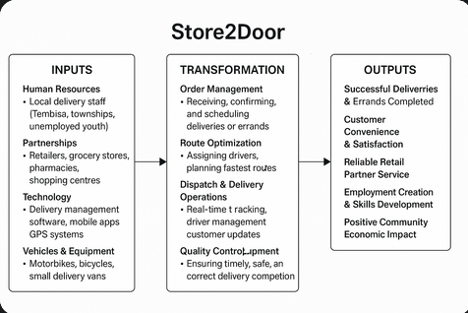
(Chatgpt.com, 2025)
The transformational model offers a clear framework to understand how Store2Door converts resources into valuable services while contributing to community development. This model consists of three core elements: inputs, transformation processes, and outputs (Slack et al., 2020).
Inputs include the essential resources that drive Store2Door’s operations. A key input is human resources, sourced primarily from disadvantaged communities such as Tembisa, providing employment opportunities and addressing local unemployment (Statistics South Africa, 2024). Strategic partnerships with retailers, pharmacies, and shopping centres ensure a steady flow of delivery contracts (Takealot Group, 2023). Store2Door also invests in technology, including delivery management software, GPS tracking, and mobile applications to coordinate orders and improve efficiency (Kotler and Keller, 2016). Financial capital is secured through investors, grants, and social enterprise funding, which supports both business operations and community programs (Bidvest Group, 2024). Finally, customer orders received via online platforms, apps, or phone calls initiate the delivery process.
The transformation process is where value is created. Orders are received, scheduled, and assigned to drivers using route optimization systems that reduce delivery times and costs (Hill and Hill, 2011). Real-time dispatching and GPS tracking allow for efficient monitoring and constant customer updates, improving transparency and service reliability (Chase et al., 2006). Quality control ensures that deliveries are accurate and on time, fostering customer trust. Store2Door also emphasizes staff training, equipping employees with customer service, safety, and operational skills that enhance both service quality and employee development (Statistics South Africa, 2024). Furthermore, Store2Door’s social impact activities include mentorship and continuous upskilling, contributing to long-term community empowerment.
Outputs reflect the outcomes of these operations. Store2Door consistently delivers on its promise of timely and reliable services, resulting in high customer satisfaction (Hayes et al., 2005). Retail partners benefit from efficient, affordable delivery services that enhance their competitiveness. Most importantly, Store2Door creates meaningful employment opportunities and facilitates skills development within underprivileged communities, generating sustainable economic growth (Hill and Hill, 2011; Statistics South Africa, 2024).

4.6 Business approach to planning and management
Store2Door needs a successful strategic plan to best operate for the future. GDI (2023) explains that there are key steps in successful strategic planning, mentioned below:

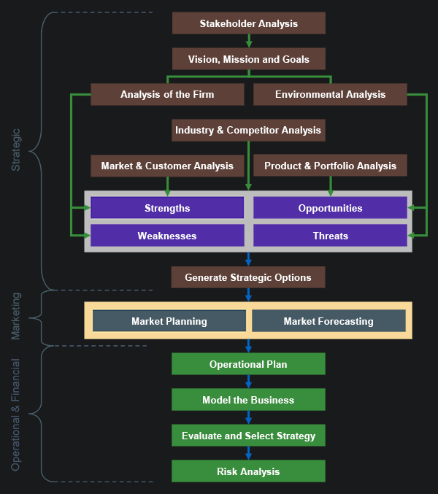
(GDI, 2023)
Further steps also include:
- Define stakeholder expectations and establish objectives for the business. (GDI, 2023)
- Describe the organization’s mission, vision and fundamental values. (GDI, 2023)
- Evaluate the environment in which the business operates. (GDI, 2023)
- Analyze the specific industry and suppliers – determine company’s strengths and weaknesses relative to competitors.
- Monitor performance.

4.8 Contract of employment

Also, referto notes in the Basic Conditions of employment included in this manual)
Strictly private and confidential
Entered into between
STORE2DOOR
_____________________________________________________
(Herein after also referred to as “the employer” or “the company”)
and
__________________________________
(ID ________________________)
(Herein after referred to as “the employee”)
Terms and conditions of employment
The terms and conditions set out herein will constitute the employee’s contract with the company with effect from ____(Date of signage)______________. Where a basic condition of employment is not specifically mentioned, the relevant legislation will be applicable (eg. the Basic Conditions of Employment Act, Act 75 of 1997, the Labour Relations Act, Act 66 of 1995 amendments to legislation etc.).
Job description
JOB TITLE
____Administrator______________.
DUTIES
The duties of this position are set out in the Duty Sheet annexed hereto as annex A. The Duty Sheet forms part of this contract. Subsequent changes thereto may only be affected in consultation with the employee.
Although the employee has been employed in the position referred to in paragraph 2.1 and will therefore be responsible for the duties referred to in paragraph 2.2.1 supra, he/she may be required to perform other duties that may reasonably be expected of him /her within the company from time to time.
During the period of employment within the company the employee will report as per company name Organisation Chart and obey instructions given by him/her and any other person duly authorised (or delegated) by the company to do so.
Termination of employment
This contract of employment may be terminated only on notice of not less than-
one week, if the employee has been employed for six months or less;
two weeks, if the employee has been employed for more than six months but not more than one year;
four weeks, if the employee –
has been employed for one year or more; or
is a domestic worker who has been employed for more than six months
Probation
(Insert period if applicable)
Remuneration
The employee’s total monthly remuneration will be R____8000______, payable in arrears on the 3rd last working day of each month. Should the regular payment date fall on a weekend or public holiday, the employer will pay the salary on the last working day before said day.
Remuneration will include the following:
Basic salary R__8000______
Total R___8000_____
The following will be deducted from the salary:
- PAYE
- UIF
Benefits
Annual Bonus at Company Discretion: (See notes on 13 th cheques elsewhere in this manual)
Profit Sharing at Company Discretion: See notes on 13 th cheques elsewhere in this manual)
Annual salary negotiation
Remuneration will be revised on an annual basis.
Working hours
Normal working hours will be from _____(08:00) to ________(16:30) from Mondays to Fridays.
The employer may not require or permit the employee to work more than forty-five (45) hours per week, calculated as follows:
Nine (9) hours on any day, if the employee works five (5) days or less a week; or
Eight (8) hours on any day if the employee works on more than five (5) days in a week; and
Lunch breaks are not included in this calculation.
Hours of work in terms of item 5.2 may be extended by up to fifteen (15) minutes a day, but may not exceed one (1) hour a week. The reason for this provision is to allow the employee to finish the task at hand, especially when serving a client, at the end of a working day.
Meal intervals
The employee is entitled to a lunch break of 60 minutes. Lunch breaks will be taken from 13:00 to 14:00 daily.
Overtime
Limit on overtime
The employee may be permitted or requested to work overtime from time to time when needed, provided that the daily overtime shall not exceed three (3) hours a day and a total of ten (10) hours a week.
Remuneration in respect of overtime
The employer shall calculate overtime remuneration at no less than 1.5 (one and one-half) the employee’s hourly wage for each hour of overtime worked; or
Pay the employee no less than the employee’s ordinary wage for each hour of overtime worked and grant the employee at least thirty (30) minutes time off with full pay for every hour of overtime worked; or
The remuneration method in 7.2.1 above will be the normal method of remuneration. Should the employer need to use one of the other options due to circumstances, he/she will inform the employee accordingly, preferably in writing, before the commencement of overtime.
Work on Sundays and Public Holidays
Sundays
Work on Sundays will not be compulsory but will be agreed on by the parties to the best interest of the company and the employee from time to time.
Public holidays
The employee will be entitled to the following official public holidays on full pay:
*New Year’s Day *Youth Day
*Human Rights Day *National Women’s Day
*Good Friday *Heritage Day
*Family Day *Day of Reconciliation
*Freedom Day *Christmas Day
*Worker’s Day *Day of Goodwill
Any other holiday declared by Government from time to time will also be granted with full pay.
Remuneration
If the employee does not work on a public holiday, he/she shall receive normal payment for that day.
If the parties agree that the employee should work on any of the above days, the employee shall be paid double the normal day’s wage for a full day or double the hourly wage for every hour worked.
The employer may also by agreement grant two (2) paid working days off in lieu of payment.
Annual leave
The employee is entitled to (21) twenty one working days leave per annum.
Leave will not be granted concurrently with any other period of sick leave granted.
Leave will normally not be granted within the notice period regarding termination of service.
Leave may not be accumulated for more than eighteen (18) months, except where explicit written consent is obtained, detailing the amount of leave which may be accumulated. Motivated written application must be made to obtain such consent.
Leave accumulated in terms of special permission referred to above will not be paid out at termination of service. Leave may thus not be accumulated for purposes of inflating a severance package.
Leave must be applied for in writing in the form and manner prescribed by the company from time to time and may only be taken after approval by the company or its delegated authority.
Sick leave
During every sick leave cycle (12 months) the employee will be entitled to an amount of sick leave equal to the number of days the employee would normally work during a period of four (4) weeks. The employee will therefore be entitled to ten (10) days sick leave over a period of twelve (12) months (1 years).
During the first six (6) months of employment the employee is entitled to one day’s paid sick leave for every twenty-one (21) days worked.
In the case where the employee is unable to attend work due to medical reasons, the employee must ensure that the company is notified as soon as reasonably possible.
An application for sick leave must be supported by a certificate from a registered medical practitioner.
Family responsibilities leave
The employee will be entitled to three (3) days family responsibility leave during each leave cycle (12 months).
Paragraph 11.1 only applies to an employee who:
Has been employed with the employer for longer than four (4) months; and
Works at least four (4) days a week for the employer.
Paragraph 11.1 only applies to an employee who:
Has been employed with the employer for longer than four (4) months; and
Works at least four (4) days a week for the employer.
The employer is only obliged to grant family responsibility leave under the following circumstances:
When the employee’s child is born; or
When the employee’s child is sick; or
In the event of death of the employee’s spouse or life partner, parent or adoptive parent, grandparent, child, adopted child, grandchild or sibling.
Leave without remuneration
Leave without remuneration may be granted when the employee’s:
Sick leave credits are insufficient or have been depleted; or
Application for sick leave cannot be reasonably substantiated; or
Family responsibility leave credits are insufficient or have been depleted and no vacation leave credits are available.
The employee may apply in writing to be granted leave without remuneration for an extended period not exceeding six (6) months in exceptional circumstances. The application will be fully motivated. The employer is not obliged to approve such an application.
If the employee is absent from duty without prior arrangement or permission, the employer may regard any period of such absence as leave without remuneration. This does not preclude the employer from taking disciplinary measures against the employee in terms of this contract.
Leave without remuneration will affect the accumulation of vacation leave credits on a pro-rata basis.
Leave without remuneration may affect the calculation of any bonus or reward that the employer may contemplate.
Deductions from remuneration
The employer may not deduct any monies from the employee’s salary unless the employee has agreed thereto in this contract or in writing on each occasion.
Trade secrets/confidentiality
The employee undertakes, without prejudice to any general duty of confidentiality, not to disclose during the continuance of this contract or afterwards, any of the trade secrets of the employer or any information which is confidential to the employer’s business. Trade secrets include the following, which list will not be regarded as exhaustive man-hour tariffs, logistic techniques, proposal contents, client contacts, etc.
The employee further undertakes immediately after the termination of his/her services to hand over to the employer all documentation and data in his /her possession belonging to the employer, whether in hard copy, contained on computer disc or any other recording medium, including documents made by him /her in the course of his/her employment. The aforementioned implies that any copy, abstract, or any precis of any document belonging to the employer made by the employee, or any other person shall itself belong to the employer.
The employee will not be liable to the employer for information divulged in terms of legislation or a court order compelling him/her to do so.
Restraint of trade
The employee may not for a period of six (6) months from the date of termination of this contract, whether on his/her own behalf or on the behalf of any other person, close corporation, partnership or company solicit custom from, deal with or supply any person, close corporation, partnership or company with whom the employer dealt at any time during his/her employment.
Paragraph 16.1 also applies to potential clients in which the employer has shown interest or with whom the employer was negotiating at the time of the employee’s employment in the company.
This limitation of trade is restricted to the nature of the employer’s business, products and services.
This limitation can be waived should both parties so agree.
Exclusive service
The appointment under this contract is a full-time appointment and the employee shall devote his/her full commitment, energy and attention to the employer’s business.
The employee shall not at any time during the continuance off this contract be directly or indirectly engaged, concerned or interested, whether for reward or otherwise, in any other trade, business or profession without the explicit written consent of the employer.
Policies, grievance and disciplinary procedure
The employee will be subject to the company’s disciplinary procedure, code of conduct and policies as determined and amended from time to time.
The Disciplinary Procedure and Code of Conduct is annexed hereto as annex B, and forms part of this contract.
Grievances or problems can be raised through the stipulated internal communication channels.
General
Any changes to this agreement will only be valid if they are in writing and have been agreed upon and signed by both parties.
Thus, done and signed at ………………………… on this, the ……………. day of …………………………… 2005.
…………………………. ………………………….
Employer Employee
…………………………. ………………………….
Witness Witness

(Andre, 2010)

- CONCLUSION

Store2Door offers a unique and sustainable service model that not only addresses logistical needs for both retail partners and individual clients but also delivers meaningful social impact by empowering disadvantaged communities through employment. By strategically leveraging local human resources, technology, and partnerships, Store2Door operates efficiently while contributing to South Africa’s broader socio-economic development goals.
The application of the transformational model demonstrates Store2Door’s ability to convert resources into reliable services while maintaining customer satisfaction, operational excellence, and community development. This integrated approach positions Store2Door as both a competitive business and a socially responsible enterprise in South Africa’s evolving service sector.
With a scalable business model, growing market demand for convenient delivery solutions, and a commitment to uplifting underprivileged communities, Store2Door is well-positioned for sustainable growth and long-term success.

- REFERENCE LIST

Andre, 2010. Contract of Employment : Example. [online] Labour Guide South Africa. Available at: https://labourguide.co.za/employment-condition/contract-of-employment-example. [Accessed 4 June 2025]
Asset Auctions, 2019. Office Furniture, IT Equipment & Vehicle Auction | Asset Auctions. [online] Available at: <https://online.assetauctions.co.za/auctions/4-1DMZBS/office-furniture-it-equipment-vehicle-auction> [Accessed 8 Jun. 2025].
ASWD, 2017. How Much Does a Website Design Cost in South Africa? | Web Design Prices. [online] Advertising Solutions Web Design. Available at: <https://advertisingsolutions.co.za/website-design-cost-south-africa/.> [Accessed 8 June 2025]
Bidvest Group, 2024. Annual Integrated Report 2024. [online] Available at: <https://www.bidvest.co.za/investor-reports.php> [Accessed 21 June 2025].
Binary Stream, 2024. The definitive guide to flat-rate billing. [online] Available at: <https://binarystream.com/the-definitive-guide-to-flat-rate-billing/> [Accessed 1 June 2025].
Bennett, T, 2023. Time-Based Pricing: Definition, Examples & Drawbacks. [online] Available at: https://priceva.com/blog/time-based-pricing [Accessed 1 June 2025].
Campbell, A, 2017. 10 Local Marketing Strategies That Work. [online] Available at: <https://www.sba.gov/blog/10-local-marketing-strategies-work> [Accessed 2 June 2025].
Cambridge Dictionary, 2019. CUSTOMIZATION | meaning in the Cambridge English Dictionary. [online] Cambridge.org. Available at: https://dictionary.cambridge.org/dictionary/english/customization.> [Accessed 17 June 2025]
Canva, 2020. Canva. [online] Available at: <https://www.canva.com/design/DAGoi3lfFGs/GDF48XSiaHRIaoBZocdWvQ/edit> [Accessed 26 May 2025].
Chatgpt.com. (2025). ChatGPT. [online] Available at: <https://chatgpt.com/c/68559bf8-c5f0-8013-ac9c-8925ed4d87e2 [Accessed 22 Jun. 2025].
Charman, A, 2017. Micro-enterprise predicament in township economic development: Evidence from Ivory Park and Tembisa. South African Journal of Economic and Management Sciences, 20(1). <doi:https://doi.org/10.4102/sajems.v20i1.1617.>[Accessed 29 May 2025]
Chase, R.B., Aquilano, N.J. and Jacobs, F.R., 2006. Operations Management for Competitive Advantage. 11th ed. Boston: McGraw-Hill.
Crawford, S, 2024. The Power Of In-Person Marketing: Why It Matters In 2023. [online] Available at: <https://inkbotdesign.com/in-person-marketing/.> [Accessed 2 June 2025]
DHL, 2024. Marketing Strategies for South African Small Businesses. [online] Available at: <https://www.dhl.com/discover/en-za/small-business-advice/growing-your-business/marketing-strategies-for-south-african-small-businesses> [Accessed 2 June 2025].
Edureka, 2022. What Is The Transformation Process In Operations Management? [online] Edureka. Available at: <https://www.edureka.co/blog/transformation-process-in-operations-management/.>[Accessed 17 June 2025]
Erasmus, B, Rudansky-Kloppers, S, and Strydom, J, 2019. Introduction to business management. 11th ed. South Africa: Oxford University Press Southern Africa (Pty) Ltd. [Accessed 21 June 2025]
Fitzsimmons, J.A. and Fitzsimmons, M.J., 2013. Service management: operations, strategy, information technology. 8th ed. New York: McGraw-Hill Education.
Gaines, M, 2011. How to Market an Errand Business. [online] Available at: <https://smallbusiness.chron.com/market-errand-business-10794.html> [Accessed 2 June 2025].
Gandy, D, n.d.. Home free vector icons designed by Dave Gandy. [online] Flaticon. Available at: <https://www.flaticon.com/free-icon/home_25694> [Accessed 26 May 2025].
George, S, 2022. Food Delivery Business In South Africa | Appscrip Blog. [online] Appscrip. Available at: <https://appscrip.com/blog/food-delivery-business-in-south-africa/.> [Accessed 31 May 2025]
Gorton, S, 2025. Digital Marketing Costs in South Africa for 2025. [online] Syte. Available at: <https://www.syte.co.za/digital-marketing-costs-south-africa-insyte-blog/.> [Accessed 8 June 2025].
Grand View Research, 2019. Online Food Delivery Services Market Size | Industry Report, 2019-2025. [online] Grandviewresearch.com. Available at: <https://www.grandviewresearch.com/industry-analysis/online-food-delivery-services-market.> [Accessed 29 May 2025]
Harbour and Associates, 2020. How much does it cost to register a company in South Africa? [online] Available at: <https://www.harbourassociates.co.za/seo-blog/general-business/how-much-does-it-cost-to-register-a-company-in-south-africa/.> [Accessed 8 June 2025]
Hayes, R.H., Pisano, G.P., Upton, D.M. and Wheelwright, S.C., 2005. Operations, Strategy, and Technology: Pursuing the Competitive Edge. Hoboken: John Wiley & Sons.
Hill, T. and Hill, A., 2011. Operations Management. 3rd ed. London: Palgrave Macmillan.
Heizer, J., Render, B. and Munson, C., 2017. Operations management: sustainability and supply chain management. 12th ed. Boston: Pearson.
iponline.cipc.co.za, n.d.. IPOnline - CIPC Intellectual Property Online. [online] Available at: <https://iponline.cipc.co.za/Trademarks/TMInformation.aspx.> [Accessed 27 May 2025]
Harper, M, 2020. What Are Key Business Processes? [online] Available at: <https://www.apqc.org/blog/what-are-key-business-processes.> [Accessed 17 June 2025]
Hi-Viz.com, 2024. Promote Your Business and Brand with Custom Printed Safety Vests. [online] Hi-Viz Safety Wear. Available at: <https://www.hi-viz.com/blogs/safety/promote-your-business-and-brand-with-custom-printed-safety-vests> [Accessed 2 June 2025].
Ivana, 2025. Checkers Sixty60 outshines Pick n Pay asap! in the On-Demand Grocery Battle. [online] Supermarket.co.za. Available at: <https://supermarket.co.za/index.php/research-tools/7142-checkers-sixty60-outshines-pick-n-pay-asap-in-the-on-demand-grocery-battle> [Accessed 31 May 2025].
Kotler, P. and Keller, K.L., 2016. Marketing management. 15th ed. Harlow: Pearson Education Limited.
Kumar, A, 2025. Top 10 Food Delivery Apps in South Africa in 2025. [online] Quick Works. Available at: <https://quick-works.com/blog/top-food-delivery-apps-in-south-africa/> [Accessed 31 May 2025].
Kumar, N., Chandarana, Y., Anand, K. and Singh, M., 2019. Using Social Media for Word-of-Mouth Marketing. [online] arXiv. <Available at: https://arxiv.org/abs/1908.08298> [Accessed 2 June 2025].
MacNeil, C, 2025. Try these 12 promotion strategies to create customer demand. [online] Asana. Available at: <https://asana.com/resources/promotion-strategy.> [Accessed 2 June 2025]
Malik, Y, 2024. Income Statement Template (download for Excel). [online] Sage Advice US. Available at: <https://www.sage.com/en-us/blog/income-statement-template/.> [Accessed 10 June 2025]
Morecroft, H, 2022. Transformational Strategy: What is it & How to Develop One? [online] Spark Strategy | Impact-led Strategy | Melbourne & Sydney. Available at: <https://sparkstrategy.com.au/transformational-strategy-what-is-it-and-how-to-develop-one/.> [Accessed 21 June 2025]
Nortonrosefulbright.com., 2015. South African private companies - Ten things to know | Global law firm | Norton Rose Fulbright. [online] Available at: <https://www.nortonrosefulbright.com/knowledge/publications/7e845fb9/south-african-private-companies.> [Accessed 27 May 2025]
O’Brien, M, 2021. 5 Subscription-Based Pricing Models, and How to Choose the Right One. [online] Oracle NetSuite. Available at: https://www.netsuite.com/portal/resource/articles/business-strategy/subscription-based-pricing-models.shtml.> [Accessed 1 June 2025]
Privateproperty.co.za, 2025. R 23 940 | 252 m2 Commercial space in Halfway House | Private Property. [online] Available at: <https://www.privateproperty.co.za/commercial-rentals/gauteng/midrand/halfway-house/1-midrand-business-park/563-old-pretoria-road/RR4394544> [Accessed 8 Jun. 2025].
Queensland Government, 2021. Break-even and profit. [online] www.business.qld.gov.au. Available at: <https://www.business.qld.gov.au/running-business/finance/essentials/break-even-profit.> [Accessed 14 June 2025]
Scootdr.com, 2025. Rent – Scoot Dr. [online] Available at: <https://scootdr.com/rent/> [Accessed 8 Jun. 2025].
Slack, N., Brandon-Jones, A. and Johnston, R., 2016. Operations management. 8th ed. Harlow: Pearson.
SME Bank of the year Global, 2021. Available at: <https://www.fnb.co.za/downloads/pricing-guide/FNB_Business_Pricing.pdf.> [Accessed 14 June 2025]
SME South Africa, 2023. A Guide for Small Business Owners for Setting up a Private Company in South Africa. [online] SME South Africa. Available at: <https://smesouthafrica.co.za/sme-guides/a-guide-for-small-business-owners-for-setting-up-a-private-company-in-south-africa/.> [Accessed 27 May 2025]
SME South Africa, 2024. How to Use WhatsApp for Small Businesses. [online] Available at: <https://smesouthafrica.co.za/how-to-use-whatsapp-for-small-businesses/> [Accessed 2 June 2025].
Shopify, 2023. 5 Low-Cost Guerrilla Marketing Tactics to Grow Your Business Offline. [online] Shopify. Available at: <https://www.shopify.com/blog/116564869-5-low-cost-guerrilla-marketing-tactics-to-grow-your-business-offline> [Accessed 2 June 2025].
Shutterstock, 2015. Shop Icon Store Symbol Flat Vector Stock Vector (Royalty Free) 293567324 | Shutterstock. [online] Available at: <https://www.shutterstock.com/image-vector/shop-icon-store-symbol-flat-vector-293567324> [Accessed 26 May 2025].
Shutterstock, 2024. 23+ Thousand Delivery Motorbike Icon Royalty-Free Images, Stock Photos & Pictures | Shutterstock. [online] Available at: <https://www.shutterstock.com/search/delivery-motorbike-icon> [Accessed 26 May 2025].
Square, 2022. What is an Advertisement? Definition, Benefits and Types l Square. [online] The Bottom Line by Square. Available at: <https://squareup.com/au/en/the-bottom-line/reaching-customers/what-is-an-advertisement.> [Accessed 2 June 2025]
Stamoulis, N, 2015. Why Digital is More Effective than Traditional Advertising? [online] Brick Marketing - Digital Marketing Agency. Available at: <https://www.brickmarketing.com/blog/digital-traditional-advertising.> [Accessed 2 June 2025]
Statistics South Africa, 2024. Labour Market Dynamics in South Africa. [online] Available at: https://www.statssa.gov.za [Accessed 21 June 2025].
Stevenson, W.J., 2020. Operations management. 14th ed. New York: McGraw-Hill Education.
Stripe, 2025. Tiered pricing 101. [online] Available at: https://stripe.com/resources/more/tiered-pricing-101-a-guide-for-a-strategic-approach [Accessed 1 June 2025].
Takealot Group, 2023. About Us. [online] Available at: https://www.takealot.com/about-us> [Accessed 21 June 2025].
Van Aardt I, and Bezuidenhout, S., 2019. Entrepreneurship and new venture management. 5th ed. Goodwood, Cape Town: Oxford University Press Southern Africa
van der Walt, T, 2019. How to protect your work from copyright infringement | Gawie le Roux Institute of Law. [online] Available at: <https://gawieleroux.co.za/blog/how-protect-your-work-copyright-infringement.> [Accessed 27 May 2025].
Walls, P, 2025. 60 Marketing Ideas For An Errand Service. [online] Available at: <https://www.starterstory.com/stories/start-an-errand-service-marketing_ideas-business-ideas> [Accessed 2 June 2025].
‌Xero, 2023. Break-Even Point | Calculation. [online] Available at: https://www.xero.com/za/glossary/break-even-point-formula/.> [Accessed 14 June 2025]

